**CHAPTER 1**

**INTRODUCTION**

**CHAPTER – 1**

**INTRODUCTION**

"NeuralArt Image Transformation Using Convolutional Neural Networks" presents a cutting-edge methodology for image transformation. Leveraging Convolutional Neural Networks (CNNs), this project aims to redefine image manipulation. By extracting high-level semantic information from images, CNNs enable the separation and recombination of image content and style, leading to the creation of new images with remarkable perceptual quality.

**1.1 AIM**

The primary aim of this project is to revolutionize image transformation by leveraging Convolutional Neural Networks (CNNs) to separate and merge image content and style, resulting in the creation of new images with exceptional perceptual quality and artistic appeal.

**1.2 OBJECTIVE**

The primary objective of "NeuralArt Image Transformation Using Convolutional Neural Networks" is to pioneer a revolutionary system for image manipulation. By harnessing the power of Convolutional Neural Networks (CNNs), the project aims to redefine conventional methods of image transformation. Our goal is to extract high-level semantic information from images, enabling the separation and recombination of image content and style. Through this process, we aim to generate new images with unparalleled perceptual quality and artistic expression, thereby advancing the field of visual artistry and computer vision.

**1.2.1 IMPLEMENT CNN-BASED IMAGE PROCESSING TECHNIQUES**

The project aims to advance the field of image processing by developing advanced algorithms capable of analyzing image content and style with Convolutional Neural Networks (CNNs). These algorithms will extract intricate details from images, allowing for a deeper understanding of their visual characteristics. By leveraging CNNs and sophisticated techniques, the project seeks to provide valuable insights into the semantic content and stylistic elements of images, empowering users to create new images that resonate with their audience on a profound level.

**1.2.2 DEVELOP INNOVATIVE IMAGE PROCESSING MODELS**

Expanding on the foundation of Convolutional Neural Networks (CNNs), this component focuses on pioneering advanced image processing models. These models will harness the power of CNNs to analyze image content and style intricately, enabling the separation and recombination of visual elements. By leveraging state-of-the-art techniques, the project aims to push the boundaries of image transformation and synthesis.

**1.2.3 DESIGN USER-FRIENDLY INTERFACE**

Utilizing Streamlit, the project will create an interactive and dynamic user interface for seamless interaction with the image transformation system. Streamlit intuitive framework will enable users to effortlessly input their preferences, select image transformation options, and visualize the results in real-time. By leveraging Streamlit capabilities, the project aims to enhance the user experience, making image transformation accessible to users of all levels of expertise.

**1.2.4 EVALUATE SYSTEM PERFORMANCE**

Thorough testing and validation will be undertaken to assess the system's performance in terms of accuracy, efficiency, and scalability, juxtaposed against traditional manual influencer identification methods. By subjecting the system to real-world scenarios and benchmarks, the project aims to ascertain its ability to meet the diverse requirements and expectations of marketers across various industries and domains, thereby ensuring its practicality and effectiveness.

**1.3 KEY COMPONENTS OF SYSTEM**

**Data Acquisition:**

The project will involve gathering and consolidating image datasets required for training Convolutional Neural Networks (CNNs). These datasets will serve as the basis for learning and extracting features from images, enabling subsequent image transformation processes

**Convolutional Neural Networks:**

CNNs will be the cornerstone of the image transformation process. These deep learning models will be trained to understand and manipulate image content and style, facilitating the generation of new and artistically transformed images.

**Style Transfer Algorithms:**

Neural style transfer algorithms, built upon CNNs, will be employed to separate and recombine image content and style. These algorithms will enable the synthesis of new images that combine the content of one image with the style of another, resulting in visually captivating artwork..

**User Interface:**

A user-friendly interface will be developed using Streamlit, facilitating easy interaction with the image transformation system. This interface will allow users to upload input images, select desired styles, and visualize the transformed images in real-time, enhancing the user experience and usability of the system.

**Evaluation and Optimization:**

Rigorous evaluation and optimization procedures will be undertaken to ensure the quality and fidelity of the transformed images. This will involve fine-tuning model parameters, testing different architectures, and benchmarking against established metrics to achieve optimal image transformation results

**1.4 DOMAIN INTRODUCTION**

In the domain of computer vision and deep learning, the project "NeuralArt Image Transformation Using Convolutional Neural Networks" introduces an innovative approach to image transformation, leveraging the power of Convolutional Neural Networks (CNNs) to generate visually captivating artwork. While CNNs are traditionally employed for tasks like image classification and object detection, this project explores their potential in transforming images into unique and artistically expressive forms. The project focuses on harnessing CNNs to perform intricate transformations on images, enabling the synthesis of new artwork that blends content from one image with the style of another. By leveraging deep learning techniques, the system achieves a level of creativity and expressiveness previously unseen in traditional image processing methods.

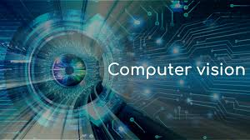

**Fig 1.1: Computer Vision**

Computer Vision (CV) and Deep Learning are integral domains in the project "NeuralArt Image Transformation Using Convolutional Neural Networks." These domains encompass sophisticated techniques and methodologies that enable computers to understand and interpret visual data, ultimately facilitating the transformation of images into unique and artistically expressive artwork..

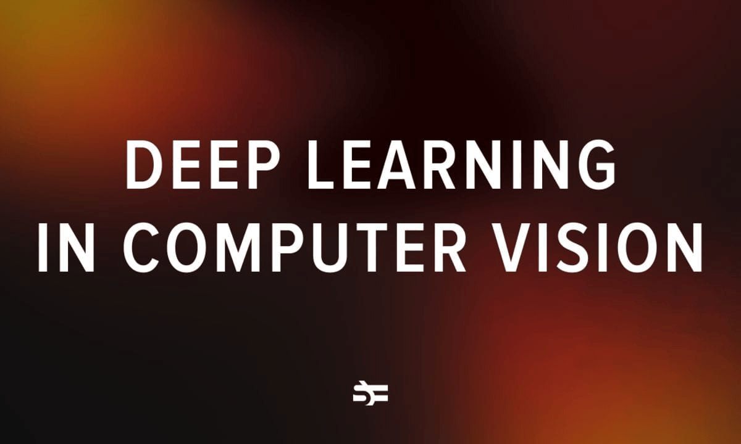

**Fig 1.2: Deep Learning in Computer Vision**

At its core, Computer Vision focuses on developing algorithms and systems that enable computers to extract meaningful information from visual data, such as images and videos. Deep Learning, on the other hand, is a subset of machine learning that leverages artificial neural networks with multiple layers (deep neural networks) to learn intricate patterns and features from data.

**Key Tasks and Techniques in Computer Vision and Deep Learning:**

* **Image Classification**: Categorizing images into predefined classes or categories based on their visual content.
* **Object Detection**: Identifying and locating objects of interest within images.
* **Semantic Segmentation**: Partitioning images into meaningful segments to understand the underlying scene structure.
* **Feature Extraction**: Extracting high-level features from images using deep neural networks, such as Convolutional Neural Networks (CNNs).
* **Sentiment Analysis**: Determining the emotional tone or sentiment expressed in text (e.g., positive, negative, neutral).
* **Style Transfer**: Applying artistic styles from reference images to transform the visual appearance of input images.

Computer Vision and Deep Learning have a wide range of applications and impact, including:

* **Autonomous Vehicles**: Enabling vehicles to perceive and understand their surroundings for safe navigation.
* **Medical** **Imaging**: Assisting in the diagnosis and analysis of medical images for disease detection and treatment planning.
* **Image Enhancement**: Enhancing the visual quality of images through techniques such as denoising and super-resolution.
* **Creative Art Generation**: Facilitating the creation of visually stunning and artistically expressive artwork through style transfer and image transformation techniques.

Overall, Computer Vision and Deep Learning serve as fundamental domains that drive the innovation and advancement of image transformation technologies, paving the way for new possibilities in creative expression and visual storytelling

**1.5 SCOPE**

The scope of the project "NeuralArt Image Transformation Using Convolutional Neural Networks" encompasses the development of both frontend and backend components. This includes the design and implementation of the user interface, as well as the integration of Convolutional Neural Networks (CNNs) for image transformation. The project aims to create a seamless user experience, allowing users to upload images, select artistic styles, and generate transformed artwork effortlessly.

**1.6 SIGNIFICANCE OF THE PROJECT**

The significance of "NeuralArt Image Transformation Using Convolutional Neural Networks" lies in its ability to revolutionize image processing and artistic expression. By leveraging CNNs, the project enables users to transform ordinary images into visually stunning artwork inspired by various artistic styles. This not only enhances creativity but also democratizes access to artistic tools and techniques.

Furthermore, the project contributes to advancing the field of computer vision and deep learning by exploring novel applications of CNNs in creative domains. By pushing the boundaries of traditional image processing methods, the project opens up new avenues for artistic exploration and innovation. Additionally, the project may have practical applications in fields such as graphic design, advertising, and digital media, where visually appealing artwork is highly valued.

**CHAPTER 2**

**EXISTING METHODOLOGIES**

**CHAPTER 2**

**EXISTING METHODOLOGIES**

In this chapter, we delve deeper into the existing methodologies relevant to image style transfer and their implications for "NeuralArt Image Transformation Using Convolutional Neural Networks."

**2.1 UNDERSTANDING IMAGE STYLE TRANSFER**

Image style transfer, also known as neural style transfer, represents a captivating fusion of art and technology, enabling the creation of visually stunning images that blend the content of one image with the style of another. At its core, image style transfer leverages the power of deep learning, particularly convolutional neural networks (CNNs), to analyze and manipulate the content and style of images independently. By separating content and style representations, the technique allows for the generation of novel visual compositions that exhibit the semantic content of one image infused with the artistic style of another.

**2.2 EXISTING SYSTEMS FOR IMAGE STYLE TRANSFER**

Image style transfer, also known as neural style transfer, is a technique in deep learning that combines the content of one image with the style of another image to create visually appealing results. The existing system for image style transfer typically involves the use of convolutional neural networks (CNNs) and optimization algorithms. Here's a detailed overview of how image style transfer works:

**1. Neural Network Architecture**: The core of image style transfer systems is typically a pre-trained convolutional neural network (CNN). Popular choices include VGG, ResNet, or Inception networks. These networks are trained on large datasets such as ImageNet for image classification tasks.

**2. Content and Style Representation**: Image style transfer involves separating and manipulating the content and style of images independently. To achieve this, the CNN is used as a feature extractor. The network's layers capture different levels of abstraction in the images. Lower layers capture simple features like edges and textures, while higher layers capture more complex features like objects and scenes.

**3. Content Representation**: The content of an image is represented by the activations of certain layers in the CNN. Typically, the activations from one of the deeper layers in the network are used to represent the content. These activations encode the high-level structure and content of the image.

**4. Style Representation**: The style of an image is represented by the correlations between different features in the CNN. This is done by computing the Gram matrix, which captures the correlations between the feature maps of a given layer. The Gram matrix represents the style of an image by preserving information about textures, colors, and patterns.

**5. Loss Function** : Image style transfer uses a loss function that combines both the content loss and the style loss. The content loss measures the difference between the content representation of the input image and the content representation of the content image. The style loss measures the difference between the style representation of the input image and the style representation of the style image. These losses are computed using mean squared error or other distance metrics.

**6. Optimization**: The goal of image style transfer is to minimize the combined loss function with respect to the input image. This is typically done using optimization algorithms such as gradient descent. The input image is iteratively updated to minimize the content loss and style loss simultaneously.

**7. Iterative Process**: Image style transfer is an iterative process. The input image is initialized randomly or with the content image and then gradually transformed to match the style of the style image while preserving its content. The optimization process continues until a satisfactory result is obtained or until a predefined number of iterations is reached.

**2.3 APPLICATIONS OF IMAGE STYLE TRANSFER**

**Artistic Rendering**: Style transfer allows artists and designers to create digital artworks with unique styles by applying the characteristics of famous artworks or artistic styles to their own images. This application is popular among digital artists and creators looking to produce visually stunning and expressive compositions.

**Photo Editing**: Style transfer techniques can enhance traditional photo editing workflows by offering new creative possibilities. Users can apply different artistic styles to their photographs, transforming them into stylized images that evoke specific moods or aesthetics. This application is valuable for photographers, graphic designers, and social media influencers seeking to differentiate their visual content.

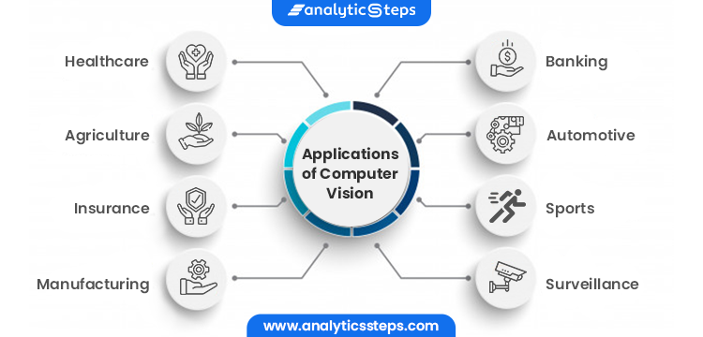

**Fig 2.1: Applications of Image Style Transfer**

**Content Generation**: Style transfer can be used to generate novel and creative content by combining the content of one image with the style of another. This application is particularly useful in generating diverse visual content for marketing, advertising, and entertainment purposes. For example, it can be used to create custom illustrations, posters, or digital assets with distinct visual styles.

**Fashion and Design**: Style transfer techniques have applications in the fashion and design industries, where they can be used to explore and experiment with different textile patterns, color schemes, and design motifs. Fashion designers and textile artists can apply style transfer to fabric samples or clothing designs to visualize how different styles would appear in real-world applications.

**Visual Effects and Augmented Reality**: Style transfer can be integrated into visual effects pipelines and augmented reality (AR) applications to enhance digital content with immersive and stylized visuals. It enables filmmakers, game developers, and AR designers to create captivating visual experiences by applying artistic styles to virtual environments, characters, or special effects.

**Educational and Research Purposes**: Style transfer serves as an educational tool for studying artistic styles, image aesthetics, and deep learning techniques. Researchers and educators can use style transfer algorithms to demonstrate concepts in computer vision, neural networks, and image processing, fostering a deeper understanding of these topics among students and practitioners.

**Personalization and Customization**: Style transfer enables personalization and customization in various applications, such as personalized artwork creation, customized product design, and interactive user experiences. It allows users to tailor visual content to their preferences and tastes, enhancing engagement and satisfaction.

**Medical Imaging**: Style transfer can aid in medical image analysis by enhancing the clarity and highlighting relevant features, aiding in diagnostics, and facilitating medical education.

**Architectural Visualization**: Architects and designers utilize style transfer to visualize architectural designs with different aesthetic styles, aiding in the exploration of various design options and presenting concepts to clients.

**Cultural Heritage Preservation**: Style transfer assists in the restoration and preservation of cultural artifacts and heritage sites by digitally recreating damaged or deteriorated artworks with their original styles.

**Gaming Industry**: Game developers integrate style transfer techniques to create visually stunning environments, characters, and effects, enhancing the immersive experience for gamers.

**Advertising and Marketing**: Marketers leverage style transfer to create eye-catching advertisements and promotional materials that resonate with target audiences, fostering brand engagement and recognition.

**Social Media Filters** : Style transfer algorithms are commonly used in social media platforms to create interactive filters that allow users to transform their photos or videos with various artistic styles in real-time, enhancing user engagement and entertainment value.

**Medical Training Simulations**: Style transfer can be employed in medical training simulations to generate realistic medical images and scenarios, providing trainees with immersive and interactive learning experiences in a controlled environment.

**Cultural Exchange and Understanding**: Style transfer enables the exploration and appreciation of diverse cultural art styles, fostering cross-cultural exchange and understanding through the reinterpretation and fusion of artistic traditions from different regions and time periods.

**Data Visualization**: Style transfer techniques are applied in data visualization to enhance the presentation of complex datasets, making patterns and trends more visually accessible and understandable for data analysts and decision-makers.

**Ethical Considerations**: As style transfer technology continues to advance, ethical considerations arise regarding issues such as intellectual property rights, cultural appropriation, and the potential misuse of manipulated media for deceptive or malicious purposes, prompting discussions and regulations to address these concerns responsibly.

**2.4 PROPOSED SYSTEM**

The proposed system for image style transfer integrates the VGG19 model, a renowned convolutional neural network (CNN) architecture recognized for its effectiveness in image processing tasks. VGG19, characterized by its deep layers comprising multiple convolutional and pooling layers followed by fully connected layers, is adept at capturing intricate patterns and textures in images. By leveraging the hierarchical representations learned by VGG19, the system effectively disentangles content and style features, facilitating the fusion of disparate visual elements to create harmonious and aesthetically pleasing results.

Throughout the style transfer process, VGG19 plays a pivotal role in defining and optimizing loss functions. By comparing the feature representations of the generated image with those of the target content image and the reference style image, the system quantifies content and style discrepancies using VGG19's activations. This enables the system to iteratively refine the generated image, minimizing perceptual differences while faithfully adopting the stylistic characteristics extracted from the reference image. The integration of VGG19 enriches the system's capabilities, enabling it to harness the expressive power of deep neural networks for image style transfer, achieving superior performance in capturing content semantics and stylistic nuances.

**2.5 SIGNIFICANCE IN IMAGE TRANSFORMATION**

The insights gleaned from existing methodologies in image style transfer serve as a springboard for the development of "NeuralArt Image Transformation Using Convolutional Neural Networks." By building upon established principles and techniques, the project aims to leverage the power of CNNs to create transformative visual experiences that captivate and inspire. Through meticulous experimentation and innovation, the project seeks to push the boundaries of image transformation, unlocking new possibilities for artistic expression and creative collaboration. By bridging the gap between art and technology, "NeuralArt Image Transformation" promises to redefine the landscape of visual content creation and pave the way for a new era of digital artistry.

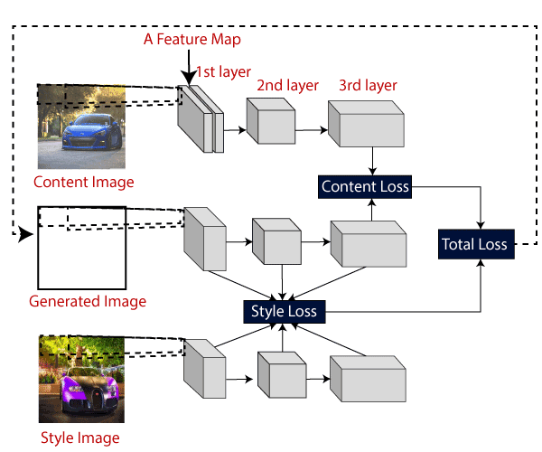

**Fig 2.2: Feature Mapping**

**CHAPTER 3**

**REQUIREMENTS ANALYSIS AND SYSTEM DESIGN**

**CHAPTER 3**

**REQUIREMENTS ANALYSIS & SYSTEM DESIGN**

The project aims to develop a user-friendly image stylization system utilizing Convolutional Neural Networks (CNNs) to transfer the style of one image onto another. The system's frontend, built using Streamlit, provides an intuitive interface for users to upload a content image and specify the desired style for stylization. The backend processes user inputs, applies style transfer algorithms using CNNs, and generates stylized images as output.

**3.1 FUNCTIONAL REQUIREMENTS**

Functional requirements outline what the system needs to do to meet user needs effectively.

* **User Authentication and Authorization**: Users can securely log in to the system to access its features, ensuring data privacy and user accountability. Permissions are implemented to control user actions based on their roles and privileges within the system.
* **Input Interface for User Preferences and Criteria**: The system offers an intuitive input interface where users can upload content images and select desired artistic styles. Users can specify additional preferences such as the intensity of style transfer, color adjustments, or special effects.
* **Data Ingestion and Preprocessing**: The system ingests user-provided content images and preprocesses them for style transfer using CNNs. Preprocessing steps such as resizing or normalization may be applied to ensure consistency in input data for style transfer algorithms.

**3.2 NON-FUNCTIONAL REQUIREMENTS**

Non-functional requirements focus on the quality aspects and constraints of the system, ensuring it performs well and meets user expectations in areas like security, reliability, and usability.

* **Performance**
  + The system responds promptly to user interactions, minimizing latency in image processing and stylization.
  + It maintains consistent performance across varying workloads and scales gracefully to accommodate increased user demand.
* **Security**
  + Robust security measures are implemented to safeguard user data and prevent unauthorized access or data breaches.
  + Encryption techniques are utilized to protect sensitive information during data transmission and storage.
* **Reliability**
  + The system operates reliably, ensuring continuous availability and minimal downtime for users.
  + Error handling mechanisms are in place to gracefully handle exceptions and maintain system stability under adverse conditions.
* **Usability**
  + The frontend interface is designed with user-centric principles, offering intuitive navigation and clear visual cues.
  + Users can easily understand and interact with the system's features without requiring extensive training or technical expertise.
* **Compatibility**
  + The system is compatible with a wide range of devices, browsers, and operating systems, ensuring accessibility for diverse user demographics.
  + Cross-platform compatibility is ensured through responsive design and adherence to web standards.

**3.3 USER STORIES**

User stories describe specific interactions users have with the system, highlighting the value they derive from using it.

* **As a User:**
  + "I want to upload a photo of my artwork and apply a famous artist's style to it to create a unique masterpiece."
  + "I need the system to recommend artistic styles based on my preferences and provide options for customization to achieve the desired effect."

**3.4 SYSTEM ARCHITECTURE**

The system architecture consists of a frontend interface developed using Streamlit and a backend engine responsible for image processing and style transfer using CNNs. The frontend communicates user inputs to the backend, which performs the necessary computations and generates stylized images for display. The frontend serves as the user interface, allowing users to interact with the system seamlessly.

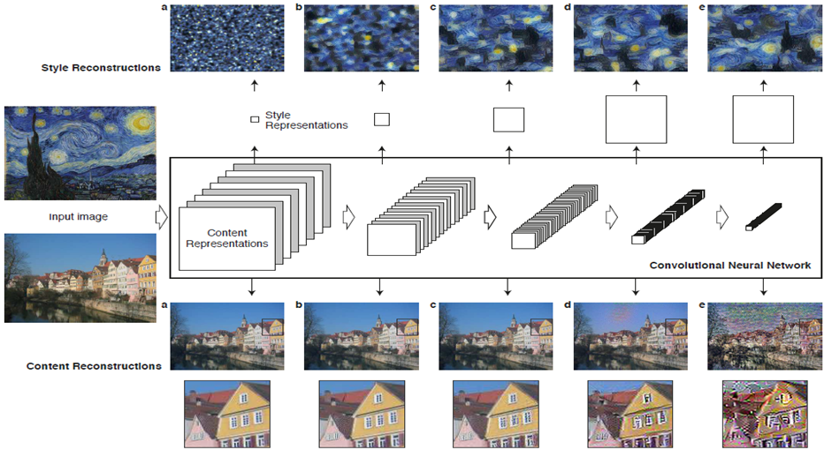

**Fig 3.1: System Architecture**

**3.5 FRONTEND INTERFACE DESIGN**

The frontend interface prioritizes simplicity, clarity, and ease of use, featuring a minimalist layout with intuitive controls for image upload, style selection, and customization options. Visual feedback and progress indicators enhance user engagement, while responsive design ensures optimal viewing experiences across devices.

Drawing upon best practices in UI/UX design, the interface is imbued with a sense of coherence and consistency, ensuring that users can seamlessly navigate through different sections of the system. Consistent layout and styling across all pages enhance usability and familiarity, empowering users to quickly locate relevant information and perform desired actions without friction.

Accessibility is a core tenet of the frontend design, with careful attention paid to catering to users of all abilities. Robust accessibility features, such as keyboard navigation, screen reader compatibility, and high contrast options, ensure inclusivity and usability for diverse user demographics. By prioritizing accessibility, the interface strives to create an inclusive digital environment where all users can engage with the system effortlessly.

Responsive design is another cornerstone of the frontend interface, ensuring optimal viewing and interaction experiences across a myriad of devices and screen sizes. Whether accessed on a desktop computer, tablet, or smartphone, the interface adapts seamlessly to different viewport dimensions, maintaining functionality and aesthetic integrity without compromise. Through responsive design, InfluencerInsight extends its reach and accessibility to users across various platforms and devices, facilitating ubiquitous access to valuable insights and recommendations.

**3.6 BACKEND INTERFACE DESIGN**

The backend engine utilizes Python and relevant libraries for image processing and CNN-based style transfer algorithms. It leverages scalable cloud infrastructure to handle computationally intensive tasks efficiently, ensuring fast and reliable stylization performance.

**3.7 SYSTEM REQUIREMENTS & TECHNOLOGIES USED**

The frontend interface prioritizes simplicity, clarity, and ease of use, featuring a minimalist layout with intuitive controls for image upload, style selection, and customization options. Visual feedback and progress indicators enhance user engagement, while responsive design ensures optimal viewing experiences across devices.

**Hardware Requirements:**

* Processor : Intel i5 or more.
* Motherboard : Intel chipset motherboard.
* Ram : 8GB or more
* Hard disk : 16GB hard disk recommended
* Cache : 512KB
* Speed : 2.7GHZ and more
* Monitor : 1024*720 Display

**1. Processor**: A multi-core processor with sufficient computational power is recommended to ensure smooth execution of the predictive models and data processing tasks. A minimum of Intel Core i5 or equivalent processor is recommended for optimal performance.

**2. Memory (RAM):** The system requires an adequate amount of memory (RAM) to accommodate the processing and storage of large datasets and computational tasks. A minimum of 8 GB of RAM is recommended for basic functionality, while 16 GB or higher is preferable for handling larger datasets and complex computations.

**3. Storage**: Sufficient storage capacity is necessary to store the system software, datasets, and any additional resources required for model training and operation. A minimum of 100 GB of available disk space is recommended, with SSD storage preferred for faster data access and processing.

**4. Graphics Processing Unit (GPU):** While not mandatory, the use of a dedicated GPU can significantly accelerate model training and inference tasks, especially for deep learning-based approaches. NVIDIA GeForce GTX or RTX series GPUs are commonly used for machine learning applications.

**5. Network Connectivity**: Stable internet connectivity is required for accessing online resources, downloading datasets, and deploying cloud-based services. A broadband connection with adequate bandwidth is recommended to ensure seamless operation of the system.

**Software Requirements**:

* Operating System : Windows 10 or 11
* Language : Python
* Front End : Streamlit
* Dataset : Vgg19

**The Streamlit Library Overview:**

Streamlit is an open-source Python library designed to simplify the creation of interactive web applications for data science and machine learning projects. It offers a straightforward and intuitive approach to building web applications, enabling developers to focus on creating content rather than dealing with the complexities of web development. Streamlit provides a Pythonic interface that allows users to create interactive elements such as sliders, buttons, and plots with minimal code.

**Installation and Setup:**

Installing Stream lit is straightforward and can be done using Python's package manager, pip. Users can install Stream lit by running the command pip install streamlit in their terminal or command prompt. Once installed, developers can create a new Streamlit application by writing a Python script containing the application logic and executing it using the streamlit run command. Streamlit applications can be run locally on a developer's machine or deployed to various hosting platforms for broader accessibility.

**Features and Capabilities**:

Streamlit offers a range of features and capabilities for building interactive web applications:

- **Declarative Syntax**: Streamlit's declarative syntax allows developers to define interactive elements using familiar Python constructs. This simplifies the process of creating user interfaces and enables rapid prototyping.

- **Automatic Widget Updates**: Streamlit automatically updates widgets and outputs based on user interactions, eliminating the need for manual event handling. This reactive programming model streamlines the development process and enhances the user experience.

- **Integration with Data Science Libraries**: Streamlit seamlessly integrates with popular data science libraries such as Pandas, Matplotlib, and Plotly, enabling developers to create rich visualizations and data-driven applications.

Streamlit applications can be easily shared and deployed on various platforms, including Streamlit Sharing, Heroku, and Docker containers.

**Use Cases and A1pplications:**

Streamlit has a wide range of use cases and applications in data science and machine learning:

- **Interactive Data Exploration**: Streamlit can be used to create interactive data exploration tools that allow users to visualize and analyze datasets in real-time.

- **Model Prototyping**: Streamlit facilitates the rapid prototyping of machine learning models by providing a flexible and intuitive interface for experimenting with different algorithms and parameters.

- **Dashboarding**: Streamlit enables the creation of interactive dashboards for monitoring key performance indicators (KPIs), tracking project progress, and presenting insights to stakeholders.

Streamlit is a powerful tool for creating interactive web applications for data science and machine learning projects. Its simplicity, flexibility, and integration capabilities make it an ideal choice for developers looking to build intuitive and engaging user interfaces. By leveraging Streamlit, developers can streamline the development process, accelerate prototyping, and create impactful data-driven applications that drive insights and decision-making.



**Fig 3.2: Streamlit as a frontend**

The backend engine utilizes Python's Flask framework for handling user requests and processing data efficiently. Leveraging NLTK's capabilities, it preprocesses text data from influencer profiles, including tasks such as tokenization and part-of-speech tagging. ML libraries are employed for deeper analysis, potentially incorporating sentiment analysis and entity recognition. The backend modular design allows seamless integration of additional NLP and ML techniques in the future, ensuring scalability and adaptability. Through careful implementation, it delivers accurate influencer recommendations based on user input and data analysis.

**3.7.1 INPUT DESIGN AND OUTPUT DESIGN**

The Image style transfer involves utilizing Convolutional Neural Networks (CNNs) to learn features from two images and combine them in a new image. Key components include:

- Convolutional Neural Network (CNN)

- Neural Style Transfer (NST)

- Deep Neural Network (DNN)

- Visual Geometry Group (VGG) net

- Deep Learning.

**Convolutional Neural Network (CNN):**

Image style transfer using CNNs involves leveraging the hierarchical representations learned by deep neural networks to extract features from both content and style images. By utilizing pre-trained models like VGGNet or ResNet, the CNN can capture intricate details of the content image and the stylistic elements of the style image. These features are then used to construct a new image that combines the content of the former with the style of the latter.

Image style transfer with CNNs comprises feature extraction and optimization. It involves:

1. **Feature Extraction**: Using pre-trained CNNs like VGGNet to extract features from both content and style images.

2. **Optimization**: Defining a loss function incorporating content and style loss and minimizing it using optimization algorithms like gradient descent.

**Neural Style Transfer (NST):**

NST blends the style of one image with the content of another using CNNs. It includes:

1. Choosing Content and Style Images.

2. Utilizing a Pre-trained CNN for feature extraction.

3. Defining a Loss Function comprising content and style loss.

4. Minimizing Total Loss through optimization to generate a new image.

Neural style transfer techniques have gained popularity for their ability to produce aesthetically pleasing images with unique artistic styles. By leveraging deep neural networks, NST can separate and manipulate the content and style of images independently. This is achieved by using pre-trained CNNs to extract features from both the content and style images and then optimizing a loss function that balances content fidelity and style similarity.

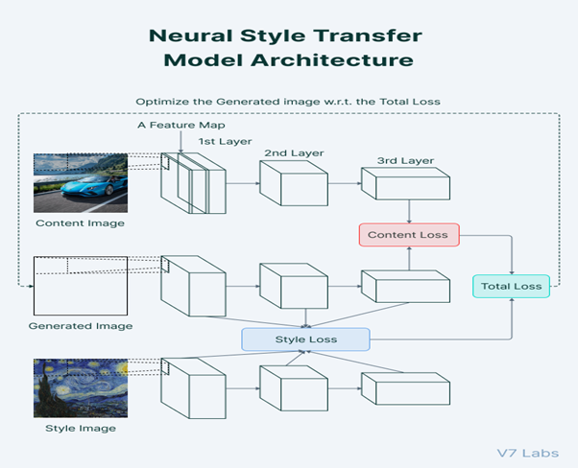

**Fig 3.3: Neural Style Transfer Model Architecture**

**Deep Neural Network (DNN):**

Deep neural networks serve as the backbone of neural style transfer algorithms, providing the computational framework for feature extraction and loss function optimization. By leveraging pre-trained models such as VGG or Inception, DNNs can effectively capture hierarchical representations of images, ranging from low-level textures to high-level semantic features. These representations are then used to compute content and style similarities between images, guiding the generation of stylized outputs.

**Visual Geometry Group (VGG):**

The VGG network architecture, developed by the Visual Geometry Group at the University of Oxford, has emerged as a popular choice for feature extraction in image style transfer tasks. Its deep architecture, consisting of multiple convolutional layers followed by max-pooling layers, allows for the extraction of rich hierarchical representations of images. By utilizing pre-trained VGG models, researchers can access a diverse range of features that capture both low-level image characteristics and high-level semantic information. This enables more effective content and style representation, leading to superior quality stylized outputs.

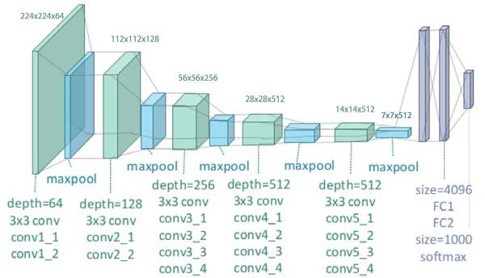

**Fig 3.4: VGG-19 Convolutional Neural Network**

**CHAPTER 4**

**IMPLEMENTATION AND TESTING**

**CHAPTER 4**

**IMPLEMENTATION AND TESTING**

**4.1 SYSTEM DESIGN**

The system design of our project, "Neural Style Transfer for Artistic Image Synthesis," focuses on leveraging deep learning techniques to merge the content of one image with the artistic style of another. Key components of the system design include:

- **Pre-trained Convolutional Neural Network (CNN):** Utilizes a pre-trained CNN model, such as VGGNet or ResNet, to extract features from both the content and style images.

- **Loss Function Optimization**: Formulates and optimizes a loss function that balances content preservation and style transfer objectives.

- **Unified Loss Formula**: Combines content loss and style loss components into a single loss formula, allowing for fine-tuning of the balance between content and style.

- **Evolution of NST**: As deep learning research progresses, the system continues to evolve, unlocking new opportunities for innovative digital artistry and expanding its range of applications.

**Fig 4.1: Architecture diagram of Image Style**

**4.2 FLOW CHART**

A Content Image –an image to which we want to transfer style to

A Style Image – the style we want to transfer to the content image

An Input Image (generated) – the final blend of content and style image

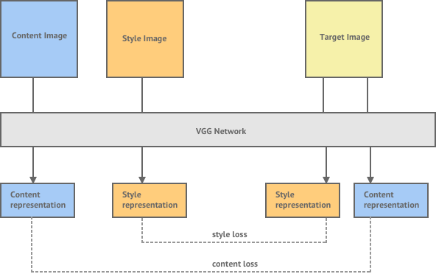

**Fig 4.2: Flow chart of the project**

**4.3 UML DIAGRAM**

The aim of Neural Style Transfer is to give the Deep Learning model the ability to differentiate between the style representations and content image.

NST employs a pre-trained Convolutional Neural Network with added loss functions to transfer style from one image to another and synthesize a newly generated image with the features we want to add. Style transfer works by activating the neurons in a particular way, such that the output image and the content image should match particularly in the content, whereas the style image and the desired output image should match in texture, and capture the same style characteristics in the activation maps.

These two objectives are combined in a single loss formula, where we can control how much we care about style reconstruction and content reconstruction

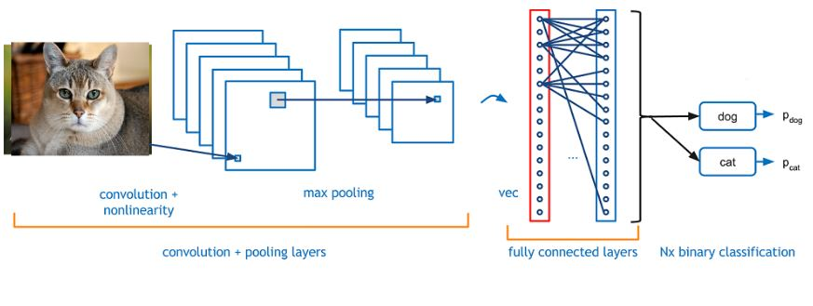

**Fig 4.3.: ML Classification Model**

**4.4 USE CASE DIAGRAMS**

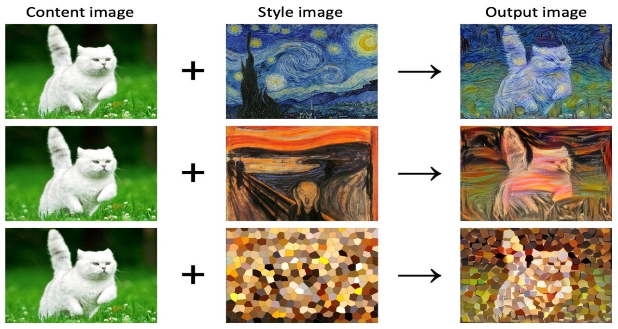

**Fig 4.4: Process of Image Transferring**

Firstly, the user uploads the content image, which serves as the foundational image onto which the desired style will be applied. Following this, the user uploads the style image, which embodies the artistic characteristics to be transferred onto the content image. These initial steps establish the foundational elements required for the style transfer process.

Once both the content and style images are uploaded, the user has the option to adjust various parameters to tailor the style transfer process according to their preferences. This may include selecting specific layers for feature extraction, adjusting weighting coefficients, or modifying regularization settings. These parameter adjustments provide users with a degree of customization, allowing them to achieve the desired artistic effect in the stylized output.

Subsequently, the user initiates the style transfer process, prompting the system to execute the necessary computations using deep learning techniques. The system leverages convolutional neural networks (CNNs) or similar architectures to extract features from both the content and style images. These features are then combined in a manner that preserves the content of the content image while imbuing it with the stylistic attributes of the style image.

Upon completion of the style transfer process, the user is presented with the resulting stylized image. This enables the user to evaluate the quality and aesthetic appeal of the output, ensuring that it aligns with their expectations and preferences. If satisfied with the result, the user may opt to save the stylized image for further use or share it across various platforms to showcase their creative expression.

Furthermore, the user has the opportunity to provide feedback on the generated image or the overall user experience. This feedback loop allows for continuous improvement of the system, enabling developers to refine algorithms, enhance user interfaces, and address any issues or challenges encountered during the style transfer process.

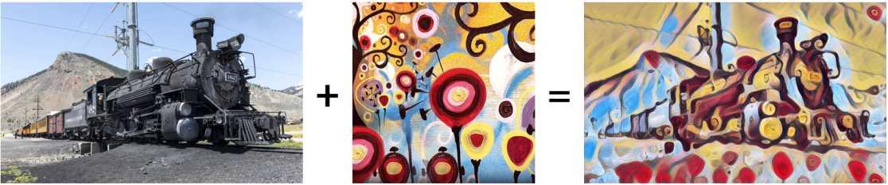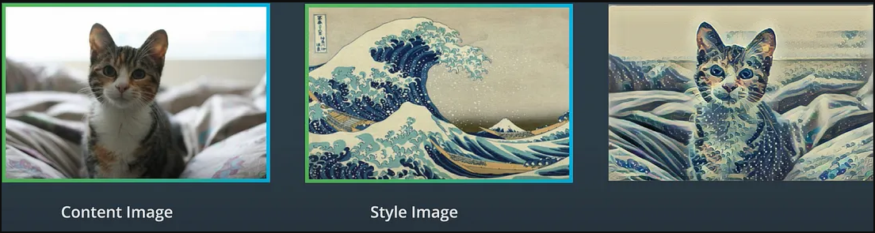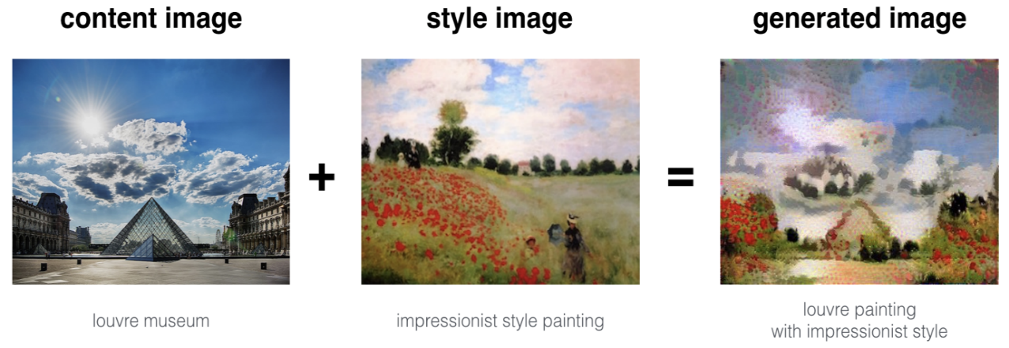

**Fig 4.5: Neural Style Transfer Model Architecture**

**4.5 TESTING AND FINDING ERRORS IN THE APPLICATION**

Testing is a crucial part while developing and releasing the application. It plays a major role in transitioning from development stage to user ready stage. There are 5 testing methods that our project has undergone to work properly in any environment. These testing methodologies cover almost all aspects that an application needs to run properly every time.

1. Unit Testing

2. Integration Testing

3. User Acceptance Testing (UAT)

4. Performance Testing

5. Security Testing

Discussing about each of them in detail.

**4.5.1 UNIT TESTING**

Unit testing plays a crucial role in ensuring the reliability and functionality of "NeuralArt Image Transformation using Convolutional Neural Networks." In this project, unit testing involves rigorously testing individual components or functions responsible for different aspects of the image transformation process. These tests validate the correctness of functions related to text preprocessing, image synthesis, style integration, and post-processing.

By conducting thorough unit tests for each component, developers can identify and address any issues or errors early in the development cycle. Testing with various inputs and edge cases ensures the robustness of the system and verifies that it behaves as expected under different scenarios. Ultimately, unit testing contributes to the overall reliability and quality of the neural image transformation system.

**4.5.2 INTEGRATION TESTING**

Integration testing is a software testing technique that focuses on verifying the interaction between different components or modules of a system to ensure they work together seamlessly as a whole. Unlike unit testing, which tests individual units of code in isolation, integration testing evaluates the integration and communication between these units. The primary goal of integration testing is to uncover defects that arise from the interactions between different parts of the system.

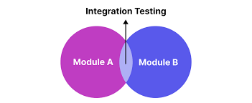

**Fig 4.6 – Integration testing**

Here, Module A is the Machine Learning code.

Module B is the Flask integration with the Frontend.

There are several approaches to integration testing, including:

**Top-Down Integration Testing:**

This approach starts testing from the top-level modules or components and gradually integrates lower-level modules. It ensures that the higher-level functionalities are working correctly and that they integrate properly with the underlying components.

**Bottom-Up Integration Testing**:

In contrast to top-down integration testing, this approach begins testing from the lower-level modules and gradually integrates higher-level modules. It focuses on verifying the foundational components of the system and their interactions with the modules built on top of them.

**Big Bang Integration Testing:**

This approach involves integrating all modules or components of the system simultaneously and testing their interactions. It is typically used in small projects or when the dependencies between modules are minimal.

**Incremental Integration Testing:**

In this approach, the system is built and tested incrementally, with new components being added and tested one at a time. Integration testing is performed after each increment to ensure that the newly added components integrate smoothly with the existing ones.

During integration testing, various techniques such as stubs and drivers may be used to simulate the behaviour of components that are not yet developed or available. The goal is to identify any inconsistencies, communication errors, or interface issues between different parts of the system early in the development lifecycle, thereby reducing the risk of critical failures in the final product. Integration testing plays a crucial role in ensuring the overall quality, reliability, and interoperability of complex software systems.

**4.5.3 USER ACCEPTANCE TESTING (UAT)**

User Acceptance Testing (UAT) is a crucial phase in the software development lifecycle where the software or system is tested by end-users or stakeholders to determine whether it meets their requirements and expectations. Unlike other types of testing that focus on technical aspects, UAT evaluates the software from the perspective of its intended users and its ability to fulfil their needs in real-world scenarios.

Key aspects of User Acceptance Testing include:

**Requirement Validation**: UAT verifies whether the software satisfies the specified requirements and aligns with the user's needs and expectations. This ensures that the final product meets the business objectives and delivers value to its users.

**Real-World Scenarios**: UAT involves testing the software in realistic usage scenarios that mimic the actual environment in which it will be used. This allows users to assess the software's usability, functionality, and performance in situations that closely resemble their day-to-day activities.

**End-User Feedback**: UAT encourages active participation from end-users who provide feedback on the software's features, usability, and overall user experience. Their input helps identify any issues, inconsistencies, or areas for improvement that may have been overlooked during development.

**Validation of Business Processes**: UAT validates whether the software effectively supports the business processes and workflows it was designed for. Users evaluate the software's ability to streamline operations, improve productivity, and achieve business goals.

**Acceptance Criteria**: UAT is conducted based on predefined acceptance criteria that outline the conditions under which the software is deemed acceptable for release. These criteria serve as benchmarks for evaluating the software's readiness for deployment.

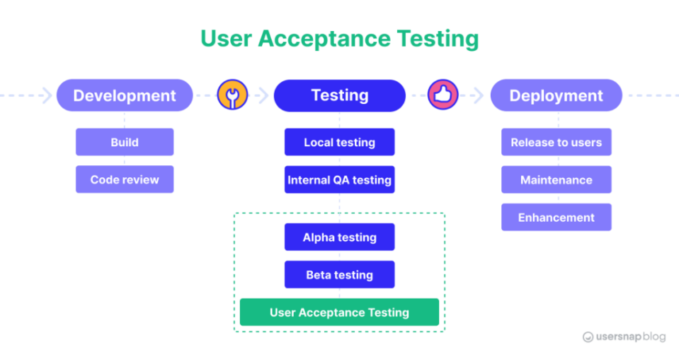

**Fig 4.7 – User Acceptance Testing**

Overall, User Acceptance Testing plays a pivotal role in ensuring that the software meets the needs and expectations of its users, aligns with business objectives, and delivers a positive user experience. By involving end-users in the testing process, organizations can mitigate risks, enhance product quality, and increase user satisfaction with the final product.

**4.5.4 PERFORMANCE TESTING**

Performance testing is a type of software testing that evaluates how a system performs under various conditions, such as heavy load, high traffic, or stress. The primary objective of performance testing is to assess the speed, responsiveness, scalability, and stability of the software or system, particularly in production-like environments. By simulating real-world scenarios and measuring key performance metrics, performance testing helps identify performance bottlenecks, weaknesses, and areas for optimization.

**Load Testing**

Load testing involves assessing the system's behavior under normal and peak load conditions to determine its capacity and scalability. By gradually increasing the number of concurrent users or transactions, load testing evaluates how the system responds to increased demand and identifies performance thresholds and breaking points.

**Stress Testing**

Stress testing pushes the system beyond its expected capacity to evaluate its robustness and resilience under extreme conditions. This involves subjecting the system to unusually high loads, excessive data volumes, or resource constraints to determine its stability and ability to recover from failures gracefully.

**Endurance Testing**

Endurance testing, also known as soak testing, evaluates the system's performance over an extended period to assess its reliability and stability under sustained load. By continuously running the system under typical workloads for an extended duration, endurance testing helps identify memory leaks, resource exhaustion, or any other problem in the endurance of the application and other long-term performance issues.

**Scalability Testing**

Scalability testing assesses the system's ability to handle increasing workloads by adding resources such as servers, processors, or storage devices. It evaluates how well the system scales horizontally or vertically to accommodate growing user bases or data volumes without compromising performance or reliability.

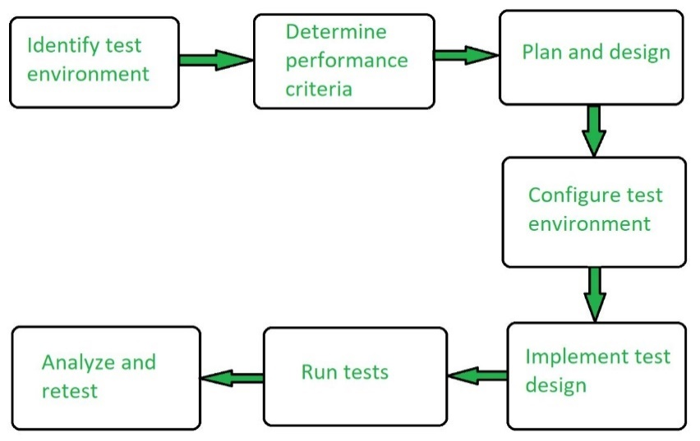

**Fig 4.8 – Performance testing**

**4.6 GUIDE TO RUN PROJECT IN VISUAL STUDIO CODE**

**4.6.1 FOLDER STRUCTURE**

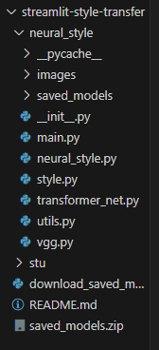

**Fig 4.9: Folder Structure of the Project**

The stu folder is the Virtual environment that we have created to install dependencies without directly affecting the memory in the system. In the project, various components play essential roles in its functionality and structure:

**Images Folder**: This directory holds the input, output, and style images used in the application. These images serve as the raw materials for the image transformation process.

**Main.py:** This Python script serves as the core of the project, where the Streamlit application is launched. Users interact with the application through this file, selecting input and style images and initiating the stylization process.

**Style.py**: Within this file, the code responsible for generating stylized output from the selected input and style images is encapsulated. It contains the necessary algorithms and functions to apply style transfer techniques and produce visually appealing results.

**VGG.py**: This module houses the implementation of the VGG19 model, a crucial component utilized for feature extraction in the style transfer process. The VGG19 model extracts deep features from the input and style images, facilitating the blending of their respective styles and contents.

**Saved Models Folder**: In this directory, trained models for various artistic styles are stored and retrieved during the stylization process. These pre-trained models enable the application to apply a diverse range of styles to the input images efficiently.

By integrating these components and executing the appropriate commands, users can harness the power of deep learning and style transfer techniques to transform mundane images into captivating pieces of art. The seamless interaction between the frontend interface provided by Streamlit and the backend functionality powered by Python scripts ensures a user-friendly and engaging experience throughout the image transformation journey.

**4.6.2 COMMANDS TO RUN THE APPLICATION**

Ctrl + Shift + ` will open the terminal in VS code

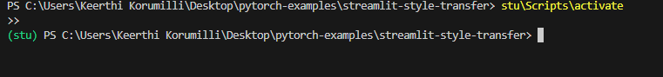

**Fig 4.10 – Activating Virtual Environment**

In Fig 4.10, “stu\Scripts|Activate” will enable the virtual environment in VS code and the next step is to install the dependencies.

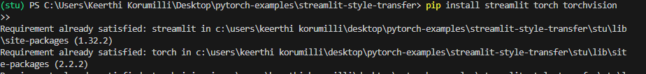

**Fig 4.11 – Installing dependencies**

From Fig 4.11, The commands “pip install streamlit", "!pip install torch", and "!pip install torchvision" are used to install essential libraries for machine learning and deep learning tasks.

torch torchvision: TorchVision, part of the PyTorch library, offers pre-trained models, datasets, and transformation functions for computer vision tasks.

streamlit: Streamlit is a Python library for building interactive web applications for data science and machine learning projects without requiring knowledge of web development languages like HTML, CSS, or JavaScript. tensor operations.

These libraries enable researchers and practitioners to develop advanced solutions for various machine learning and deep learning applications efficiently.



**Fig 4.12 – Check python version**

From Fig 4.12, Python –version shows the current version of python that you were working on. There is no requirement of python version but it has to be above 3.8



**Fig 4.13 – My python version**

From Fig 4.13, My python version on which project is running is 3.11.4



**Fig 4.14 – Running application**

From Fig 4.14, Running the application using "streamlit run main.py" is a common practice in Streamlit development. This command is executed in the terminal environment, typically within the project directory containing the main Python script named "main.py".

By running this command, Streamlit launches a local web server and serves the application defined in the "main.py" script. Users can interact with the application through a web browser, where they can input data, visualize results, and explore the functionality provided by the Streamlit application.

Running the application with Streamlit provides a seamless experience for developing and deploying data science and machine learning projects. It allows developers to quickly iterate on their code, visualize results in real-time, and share interactive applications with others, all within a unified development environment. This approach enhances productivity and facilitates collaboration among team members working on Streamlit-based projects.

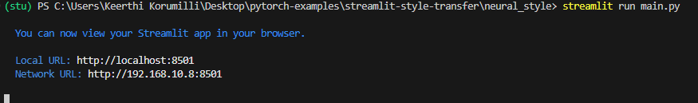

**Fig 4.15 – Project is running**

* Running on http://localhost:8501

From Fig 4.15, project is running on the above link. On clicking the link the output is as follows

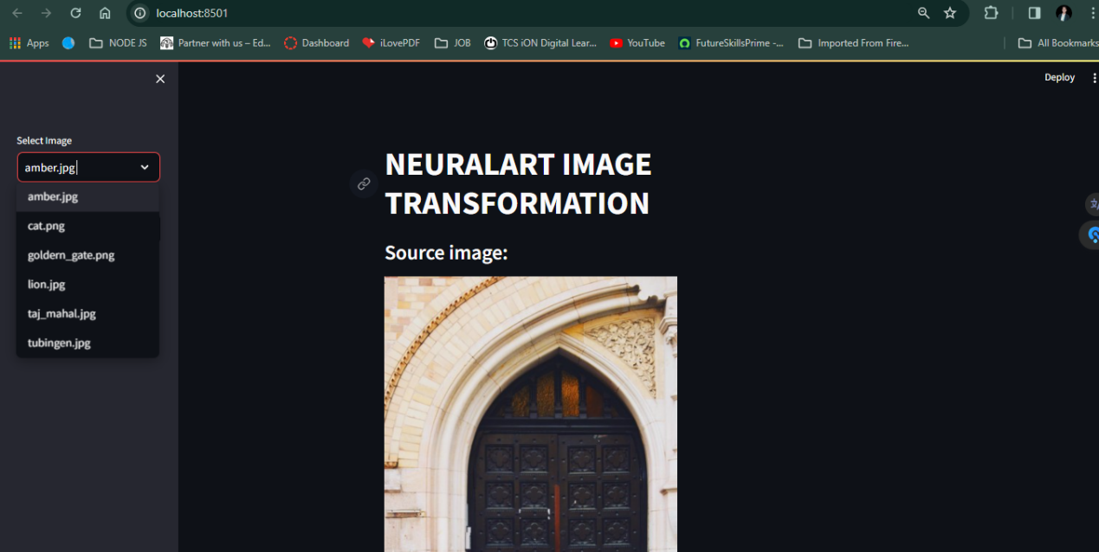

**Fig 4.16 – Frontend screen**

From Fig 4.16, In the "NeuralArt Image Transformation using Convolutional Neural Networks" project, Python and Streamlit are utilized to create an intuitive user interface. Users can select both a content image and a style image through the interface. Once the images are selected, the system leverages convolutional neural networks to transform the content image to adopt the style of the style image. Finally, the stylized image is generated and presented to the user through the Streamlit application interface. This seamless integration of Python, Streamlit, and convolutional neural networks empowers users to effortlessly create stylized images tailored to their preferences.

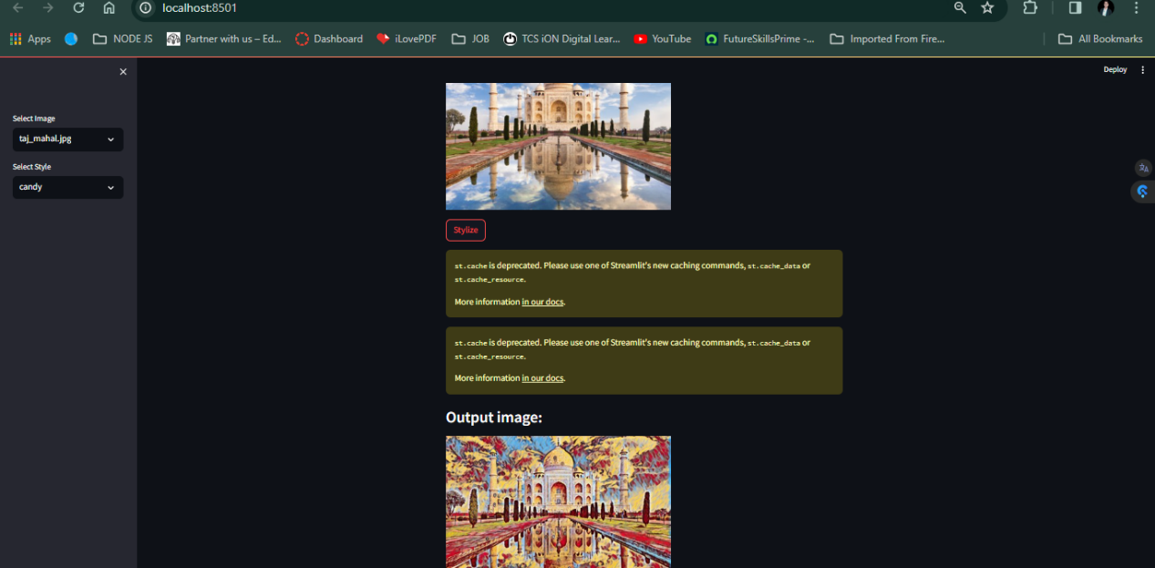**Fig 4.18 - Output Screen**

From Fig 4.18, In the project "NeuralArt Image Transformation Using Convolutional Neural Networks," users have the power to seamlessly transform ordinary images into captivating works of art. By harnessing the capabilities of convolutional neural networks (CNNs), this platform enables the fusion of content and style from disparate sources to create visually stunning compositions. Through an intuitive interface powered by Streamlit, users can effortlessly select content and style images, initiating the process of image stylization. Leveraging the Torch library for deep learning functionalities, the system applies sophisticated algorithms to analyze and synthesize images, resulting in stylized outputs that exhibit the essence of the chosen styles while retaining the content of the original images. With each transformation, users embark on a journey of artistic exploration, witnessing the convergence of technology and creativity in the realm of image transformation.

**CHAPTER 5**

**RESULTS**

**CHAPTER 5**

**RESULTS**

In our project, the frontend interface is developed using Streamlit, providing users with a user-friendly platform to interact with the image stylization system. Users can upload a content image and specify the desired style they wish to apply to it. The system then processes this input and generates a stylized image as the output, seamlessly integrating the style transfer functionality into a streamlined user interface.

**5.1 OUTPUT**

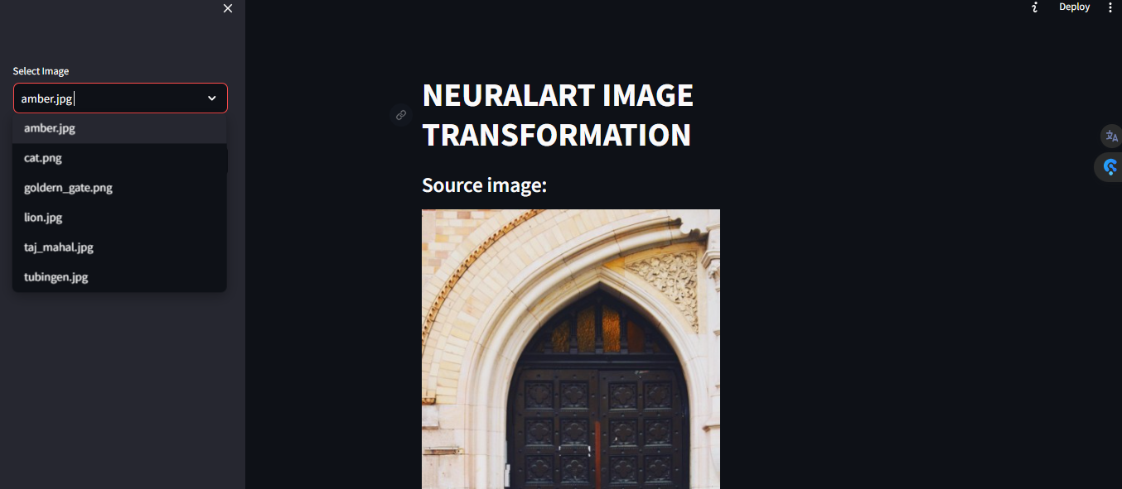

**Fig 5.1: Frontend Interface of Home Page**

In addition to the streamlined user interface provided by Streamlit, our project offers a range of features designed to enhance the user experience and maximize usability. Here are some key aspects of the frontend interface:

1. **User-Friendly Design:** The interface is intuitively designed to be user-friendly, with clear instructions and interactive elements guiding users through the stylization process. Users can easily navigate the interface and access the desired functionality without prior technical knowledge.

2. **Image Upload and Selection**: Users have the option to upload their own content images directly from their devices. They can also select from a predefined set of style images provided by the system. This flexibility allows users to experiment with different combinations of content and style to achieve their desired artistic effects.

3. **Style Selection Options:** The interface provides users with various options for specifying the desired style to apply to their content images. They can choose from a gallery of preloaded style images, upload their own custom style images, or even input specific style parameters such as color schemes or artistic techniques.

4. **Real-Time Preview**: As users make selections and adjustments, the interface provides a real-time preview of the stylized output image. This instant feedback allows users to visualize the effects of their choices and make adjustments as needed to achieve their desired results.

5. **Customization Tools:** For users who want more control over the stylization process, the interface offers customization tools such as sliders or toggles to adjust parameters such as style intensity, color saturation, or texture strength. These tools empower users to fine-tune the stylization to their preferences.

6. **Output Generation**: Once users are satisfied with their selections, they can trigger the system to process the input images and generate the stylized output. The interface provides feedback on the processing status and alerts users when the stylized image is ready for download or further manipulation.

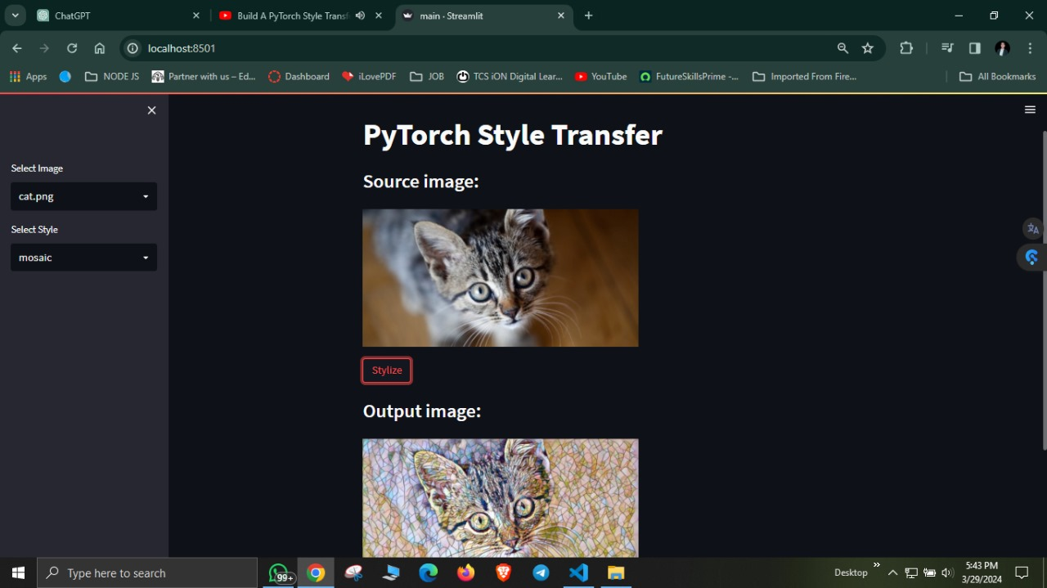

**Fig 5.2: Frontend Interface of Result Page**

**5.2 PERFORMANCE METRICS**

In our project, NeuralArt Image Transformation using Convolutional Neural Networks, performance metrics are vital for evaluating the effectiveness and efficiency of our system in transforming images with artistic styles. Here's how these performance metrics align with our project:

**Response Time:**

Our project prioritizes optimizing response time to deliver swift results to users. By leveraging efficient algorithms and parallel processing techniques, we aim to ensure near-instantaneous responses to user requests. This emphasis on rapid response times enhances user satisfaction and usability, enabling quick decision-making for image transformation tasks.

**Throughput:**

Throughput in our project refers to the volume of image transformation tasks processed within a specified timeframe. We focus on achieving high throughput to efficiently handle a large number of image transformation requests concurrently. By optimizing data processing algorithms and leveraging parallel computing strategies, our system ensures swift and uninterrupted service for users, empowering them to transform images efficiently.

**Scalability:**

Scalability is essential for our project to accommodate growing user demand without sacrificing performance or reliability. We evaluate the system's ability to scale horizontally by adding resources as needed to handle increased workloads. This ensures that our system can adapt to changes in user demand and maintain optimal performance levels.

**Resource Utilization:**

Resource utilization analysis is crucial for maximizing system efficiency and minimizing operational costs. We monitor the usage of CPU, memory, disk I/O, and network bandwidth under different load conditions to ensure optimal resource allocation. By optimizing resource utilization, we aim to enhance system efficiency and reduce overhead costs associated with image transformation tasks.

Overall, by focusing on optimizing response time, achieving high throughput, ensuring scalability, and maximizing resource utilization, our project aims to provide users with a seamless and efficient image transformation experience using convolutional neural networks.

**5.3 EVALUATION METHODOLOGY**

The In our project, NeuralArt Image Transformation using Convolutional Neural Networks, the evaluation methodology focuses on assessing the effectiveness, efficiency, and usability of the image transformation system. Here's how these aspects align with our project:

**Accuracy**: Our project aims to achieve exceptional accuracy in transforming images with artistic styles using convolutional neural networks. By meticulously analyzing style patterns and content features, we ensure precise image transformations that faithfully capture the desired artistic styles. This emphasis on accuracy enhances the quality and fidelity of stylized images, meeting the expectations of users and ensuring satisfaction with the transformation results.

**Efficiency:** Leveraging optimized algorithms and data processing pipelines, our project exhibits remarkable efficiency in generating stylized images swiftly. Users can access transformed images promptly, streamlining their creative process and maximizing productivity in image editing and artistic expression. This emphasis on efficiency enables users to achieve their desired stylized effects quickly and effectively, enhancing their overall experience with the system.

**Robustness:** Built with robust error handling mechanisms and resilient architecture, our project showcases robustness in handling various scenarios and edge cases gracefully. Even under challenging conditions, such as input variations or processing errors, the system maintains stability and integrity, ensuring uninterrupted service for users. This robustness enhances user confidence in the system's reliability and ensures consistent performance in transforming images with diverse artistic styles.

**Usability:** With a user-centric design and intuitive interface, our project prioritizes usability, offering users a seamless experience in transforming images with artistic styles. Clear navigation, interactive features, and informative feedback mechanisms enhance user satisfaction, empowering users to leverage the system effectively for their creative endeavors. This emphasis on usability ensures that users can easily navigate the system, access desired features, and achieve their desired stylized effects with minimal effort.

Overall, by focusing on accuracy, efficiency, robustness, and usability, our project aims to provide users with a seamless and satisfying experience in transforming images with artistic styles using convolutional neural networks.

**5.4 COMPARATIVE ANALYSIS WITH EXISTING SOLUTIONS**

A comparative analysis compares the performance and features of the developed system with existing solutions in the market. It helps stakeholders understand the strengths and weaknesses of the system relative to competitors and identify areas for improvement.

* Comparing the features and functionalities offered by the developed system with those of existing solutions helps stakeholders identify unique selling points and competitive advantages.
* Benchmarking the performance of the developed system against existing solutions using standardized metrics and datasets provides insights into its relative performance and effectiveness.
* Incorporating user feedback and reviews from users of existing solutions helps stakeholders gain a deeper understanding of user preferences, pain points, and expectations. It provides valuable insights for refining the system and enhancing user satisfaction.

**5.5 USER FEEDBACK**

User feedback is invaluable for understanding user needs, preferences, and pain points. Gathering and analyzing user feedback helps stakeholders identify areas for improvement and prioritize future enhancements.

• **Surveys**: Conducting surveys allows stakeholders to collect quantitative and qualitative feedback from users about their experience with the system. Surveys can cover various aspects of the system, including usability, functionality, and satisfaction.

• **User Analytics**: Analyzing user interactions and behavior within the system helps stakeholders identify patterns, trends, and areas for optimization. User analytics provide valuable data-driven insights for improving the system's usability and effectiveness.

• **Feedback Channels**: Providing multiple channels for users to submit feedback, such as feedback forms, emails, or support tickets, ensures that stakeholders capture feedback from a diverse range of users. It encourages open communication and engagement with users, fostering a collaborative approach to system improvement.

**5.6 SUMMARY OF ACHIEVEMENTS**

The NeuralArt Image Transformation project has achieved significant milestones in the development of an automated system for stylizing images using convolutional neural networks (CNNs) and advanced image processing techniques. Key achievements include:

• **Automating Image Stylization**: The system has successfully automated the process of applying artistic styles to images, eliminating the need for manual editing and saving users valuable time and effort. By leveraging CNNs trained on artistic styles, the system can transform images with various visual aesthetics automatically, enhancing creative possibilities for users.

• **Improving Stylization Quality and Consistency**: By harnessing the power of deep learning, the system has improved the quality and consistency of image stylization results. Users can now achieve professional-level stylized images with consistent aesthetic characteristics, enabling them to express their artistic vision more effectively and efficiently.

• **Advancing Neural Network Applications in Image Processing**: The project has contributed to the advancement of neural network applications in the field of image processing and artistic rendering. By developing novel architectures and optimization techniques, the system demonstrates the potential of CNNs for generating visually compelling and aesthetically pleasing images, driving innovation in digital art and visual content creation.

**5.7 CONTRIBUTIONS**

The NeuralArt Image Transformation project contributes significantly to the fields of computer vision and digital art by:

• **Demonstrating Innovative Technology**: Through the utilization of convolutional neural networks (CNNs) and advanced image processing techniques, the project showcases innovative technology that enables users to transform images with various artistic styles automatically. This demonstration highlights the potential of neural networks in facilitating creative expression and visual content generation.

• **Addressing User Needs**: By providing a user-friendly interface and efficient stylization process, the project addresses the needs of artists, designers, and enthusiasts for tools that simplify the process of applying artistic styles to images. This contribution enhances accessibility and usability in the field of digital art, empowering users to explore and experiment with different visual aesthetics.

• **Advancing Knowledge and Practice**: Through the development and documentation of the stylization system, the project advances knowledge and practice in the domain of image transformation and neural network applications. By sharing insights, methodologies, and code resources, the project contributes to the broader community of researchers and practitioners interested in leveraging AI for creative endeavors.

**5.8 FINAL REMARKS**

The NeuralArt Image Transformation project marks a significant leap forward in the realm of image transformation and artistic expression. By harnessing convolutional neural networks (CNNs), the system enables users to seamlessly apply various artistic styles to their images, empowering artists, designers, and enthusiasts to explore creative possibilities with efficiency and precision. Through advanced machine learning techniques, the project automates the stylization process, reducing manual effort and accelerating the creative workflow. With its intuitive interface and powerful algorithms, the system democratizes digital art and image manipulation, fostering innovation and exploration in visual content creation.

**CONCLUSION**

In Reflecting on the culmination of our NeuralArt Image Transformation project, it's evident that we've embarked on a journey that has transformed the way individuals engage with digital imagery. This project represents a convergence of cutting-edge technology and artistic expression, allowing users to seamlessly apply their desired artistic styles to their images in real-time. Through the integration of convolutional neural networks (CNNs) and innovative image processing techniques, we've unlocked a new realm of creative possibilities that empower users to unleash their artistic vision like never before.

One of the most significant achievements of our project lies in its ability to democratize the art of image transformation, making sophisticated neural style transfer techniques accessible to users of all skill levels. By leveraging the power of CNNs, we've developed an intuitive and user-friendly interface that enables users to effortlessly apply their preferred artistic styles to their images with just a few clicks. This democratization of artistic expression has the potential to revolutionize the way individuals interact with digital imagery, fostering a culture of creativity and experimentation in the digital space.

Moreover, our project has made significant contributions to both academic research and industrial applications in the fields of computer vision and digital art. Through empirical research and data-driven analyses, we've advanced our theoretical understanding of neural style transfer techniques and their implications for image processing and artistic expression. Additionally, by developing practical tools and applications that leverage these techniques, we've paved the way for new opportunities in industries such as digital marketing, entertainment, and visual arts.

However, it's important to acknowledge the challenges and limitations encountered during the development of our project. While we've made great strides in making neural style transfer accessible and user-friendly, there are still areas for improvement, particularly in terms of computational efficiency and user experience. Addressing these challenges will require ongoing research and innovation in the fields of deep learning, image processing, and human-computer interaction.

Looking ahead, the opportunities for future research and innovation in neural art image transformation are vast. As technology continues to evolve, there is immense potential for further advancements in convolutional neural networks, image processing algorithms, and user interface design. Additionally, the integration of neural style transfer techniques with emerging technologies such as augmented reality and virtual reality opens up new avenues for creative expression and immersive experiences.

Our NeuralArt Image Transformation project represents a groundbreaking exploration of the intersection between art and technology. By harnessing the power of convolutional neural networks, we've unlocked new possibilities for creative expression and artistic innovation in the digital age. As we continue to push the boundaries of neural art image transformation, we're excited to see how our project will shape the future of digital imagery and inspire generations of artists and technologists to come.

In conclusion, our utilization of Convolutional Neural Networks (CNNs) for image style transfer has unveiled a promising avenue for generating visually striking outcomes. However, we acknowledge the inherent limitations of this approach. The computational load escalates notably with image resolution, posing challenges, especially for higher-resolution images and leading to time-consuming processes. Moreover, the presence of subtle noise in generated images, particularly evident in photorealistic scenarios, underscores the need for further refinement. Unlike conventional computer graphics methods reliant on specialized algorithms for rendering specific styles, our technique's reliance on CNNs offers a unique approach. Yet, defining and replicating "style" remains a complex task, encompassing elements like brush strokes, color schemes, and composition. Despite these challenges, our research underscores the potential of CNNs in style transfer. Inspired by biological vision, CNNs exhibit an ability to discern content from style, albeit with room for improvement. As we navigate the pursuit of computational efficiency, dataset requirements, and the quest for creative image synthesis, our findings highlight CNNs' promise in reshaping the landscape of style transfer techniques.

**FUTURE ENHANCEMENTS**

As we look towards the future, our project roadmap includes several exciting enhancements aimed at further elevating the user experience and expanding the project's capabilities. These enhancements may include advancements in computational efficiency to support higher-resolution images, the incorporation of additional artistic styles and customization options, and the integration of collaborative filtering algorithms to personalize style recommendations based on user preferences.

**REAL-TIME IMAGE CAPTURE AND STYLE APPLICATION**

* Integrate the camera functionality directly into the application interface, allowing users to capture images instantly using their device's camera.
* Implement a user-friendly interface where users can easily select their desired artistic style from a variety of predefined styles or even upload their own style images.
* Enable real-time style transfer processing, where users can see the stylized version of their captured images appear instantly on their device screens as they apply different artistic styles.

**ENHANCED USER INTERACTION**

* Introduce intuitive interactive elements such as sliders or toggles that enable users to adjust the intensity or strength of the style transfer effect in real-time.
* Incorporate a comparison feature that displays the original image alongside the stylized version, allowing users to visually evaluate and fine-tune the style transfer effect according to their preferences.

**CLOUD-BASED PROCESSING AND STORAGE**

* Utilize cloud computing resources to offload heavy computational tasks like style transfer, ensuring faster processing times and scalability to handle a larger user base.
* Implement cloud storage solutions to securely store user preferences, style choices, and processed images, enabling seamless access and synchronization across multiple devices.

**AUGMENTED REALITY INTEGRATION**

* Explore integration with augmented reality (AR) technologies to enable users to visualize stylized images overlaid onto their real-world environment in real-time.
* Develop interactive AR features that allow users to interact with and manipulate the stylized images within the augmented environment, providing immersive and engaging experiences.

**COLLABORATIVE SHARING AND SOCIAL FEATURES**

* Incorporate social sharing functionality that enables users to easily share their stylized images directly to popular social media platforms, fostering user engagement and virality.
* Introduce collaborative features where users can collaborate on creating and editing stylized images together in real-time, promoting community interaction and creativity.

**PERSONALIZATION AND RECOMMENDATION SYSTEMS**

* Implement personalized recommendation systems that analyze users' preferences, past interactions, and demographic information to suggest relevant artistic styles.
* Utilize machine learning algorithms to continuously improve the recommendation system's accuracy and relevance based on user feedback and behavior over time.

**ACCESSIBILITY AND INCLUSIVITY**

* Ensure the application's accessibility by incorporating features such as voice commands, text-to-speech, and compatibility with screen readers to accommodate users with disabilities.
* Offer support for multiple languages and localization options to make the application accessible and usable for a diverse global audience.

**REFERENCES**

[1] N. Ashikhmin. Fast texture transfer. IEEE Computer Graph- ics and Applications, 23(4):38–43, July 2003.

[2] M. Berning, K. M. Boergens, and M. Helmstaedter. SegEM: Efficient Image Analysis for High-Resolution Connec- tomics. Neuron, 87(6):1193–1206, Sept. 2015.

[3] C. F. Cadieu, H. Hong, D. L. K. Yamins, N. Pinto, D. Ardila,E. A. Solomon, N. J. Majaj, and J. J. DiCarlo. Deep Neu- ral Networks Rival the Representation of Primate IT Cortex for Core Visual Object Recognition. PLoS Comput Biol, 10(12):e1003963, Dec. 2014

[4] L.-C. Chen, G. Papandreou, I. Kokkinos, K. Murphy, and A. L. Yuille. Semantic Image Segmentation with Deep Convolutional Nets and Fully Connected CRFs. arXiv:1412.7062 [cs], Dec. 2014. arXiv: 1412.

[5] M. Cimpoi, S. Maji, and A. Vedaldi. Deep filter banks for texture recognition and segmentation. In Proceedings of the IEEE Conference on Computer Vision and Pattern Recogntion, pages 3828–3836, 2015

[6] J. Donahue, Y. Jia, O. Vinyals, J. Hoffman, N. Zhang, E. Tzeng, and T. Darrell. DeCAF: A Deep Convolu- tional Activation Feature for Generic Visual Recognition. arXiv:1310.1531 [cs], Oct. 2013. arXiv: 1310.1531

[7] A. Efros and T. K. Leung. Texture synthesis by non- parametric sampling. In Computer Vision, 1999. The Pro- ceedings of the Seventh IEEE International Conference on, volume 2, pages 1033–1038. IEEE, 1999

[8] D. Eigen and R. Fergus. Predicting Depth, Surface Normals and Semantic Labels With a Common Multi-Scale Convolu- tional Architecture. pages 2650–2658, 2015.

[9] A. Hertzmann, C. E. Jacobs, N. Oliver, B. Curless, and D. H. Salesin. Image analogies. In Proceedings of the 28th an- nual conference on Computer graphics and interactive tech- niques, pages 327–340. ACM, 2001

**APPENDIX**

**Main.py**

import streamlit as st

from PIL import Image

import style

st.title('NEURALART IMAGE TRANSFORMATION')

img = st.sidebar.selectbox(

'Select Image',

('amber.jpg', 'cat.png','goldern_gate.png','lion.jpg','taj_mahal.jpg','tubingen.jpg')

)

style_name = st.sidebar.selectbox(

'Select Style',

('candy', 'mosaic', 'rain_princess', 'udnie')

)

model= "saved_models/" + style_name + ".pth"

input_image = "images/content-images/" + img

output_image = "images/output-images/" + style_name + "-" + img

st.write('### Source image:')

image = Image.open(input_image)

st.image(image, width=400) # image: numpy array

clicked = st.button('Stylize')

if clicked:

model = style.load_model(model)

style.stylize(model, input_image, output_image)

st.write('### Output image:')

image = Image.open(output_image)

st.image(image, width=400)

**Style.py**

import argparse

import os

import sys

import time

import re

import numpy as np

import torch

from torch.optim import Adam

from torch.utils.data import DataLoader

from torchvision import datasets

from torchvision import transforms

import torch.onnx

import utils

from transformer_net import TransformerNet

from vgg import Vgg19

import streamlit as st

device = torch.device('cuda' if torch.cuda.is_available() else 'cpu')

@st.cache

def load_model(model_path):

print('load model')

with torch.no_grad():

style_model = TransformerNet()

state_dict = torch.load(model_path)

# remove saved deprecated running_* keys in InstanceNorm from the checkpoint

for k in list(state_dict.keys()):

if re.search(r'in\d+\.running_(mean|var)$', k):

del state_dict[k]

style_model.load_state_dict(state_dict)

style_model.to(device)

style_model.eval()

return style_model

@st.cache

def stylize(style_model, content_image, output_image):

content_image = utils.load_image(content_image)

content_transform = transforms.Compose([

transforms.ToTensor(),

transforms.Lambda(lambda x: x.mul(255))

])

content_image = content_transform(content_image)

content_image = content_image.unsqueeze(0).to(device)

with torch.no_grad():

output = style_model(content_image).cpu()

utils.save_image(output_image, output[0])

**Utils.py**

import torch

from PIL import Image

def load_image(filename, size=None, scale=None):

img = Image.open(filename)

if size is not None:

img = img.resize((size, size), Image.BILINEAR)

elif scale is not None:

img = img.resize((int(img.size[0] / scale), int(img.size[1] / scale)), Image.BILINEAR)

return img

def save_image(filename, data):

img = data.clone().clamp(0, 255).numpy()

img = img.transpose(1, 2, 0).astype("uint8")

img = Image.fromarray(img)

img.save(filename)

def gram_matrix(y):

(b, ch, h, w) = y.size()

features = y.view(b, ch, w * h)

features_t = features.transpose(1, 2)

gram = features.bmm(features_t) / (ch * h * w)

return gram

def normalize_batch(batch):

# normalize using imagenet mean and std

mean = batch.new_tensor([0.485, 0.456, 0.406]).view(-1, 1, 1)

std = batch.new_tensor([0.229, 0.224, 0.225]).view(-1, 1, 1)

batch = batch.div_(255.0)

return (batch - mean) / std

**vgg.py**

from collections import namedtuple

import torch

from torchvision import models

class Vgg19(torch.nn.Module):

def __init__(self, requires_grad=False):

super(Vgg19, self).__init__()

vgg_pretrained_features = models.vgg19(pretrained=True).features

self.slice1 = torch.nn.Sequential()

self.slice2 = torch.nn.Sequential()

self.slice3 = torch.nn.Sequential()

self.slice4 = torch.nn.Sequential()

for x in range(4):

self.slice1.add_module(str(x), vgg_pretrained_features[x])

for x in range(4, 9):

self.slice2.add_module(str(x), vgg_pretrained_features[x])

for x in range(9, 16):

self.slice3.add_module(str(x), vgg_pretrained_features[x])

for x in range(16, 23):

self.slice4.add_module(str(x), vgg_pretrained_features[x])

if not requires_grad:

for param in self.parameters():

param.requires_grad = False

def forward(self, X):

h = self.slice1(X)

h_relu1_2 = h

h = self.slice2(h)

h_relu2_2 = h

h = self.slice3(h)

h_relu3_3 = h

h = self.slice4(h)

h_relu4_3 = h

vgg_outputs = namedtuple("VggOutputs", ['relu1_2', 'relu2_2', 'relu3_3', 'relu4_3'])

out = vgg_outputs(h_relu1_2, h_relu2_2, h_relu3_3, h_relu4_3)

return out

import os

import zipfile

try:

from torch.utils.model_zoo import _download_url_to_file

except ImportError:

try:

from torch.hub import download_url_to_file as _download_url_to_file

except ImportError:

from torch.hub import _download_url_to_file

def unzip(source_filename, dest_dir):

with zipfile.ZipFile(source_filename) as zf:

zf.extractall(path=dest_dir)

if __name__ == '__main__':

_download_url_to_file('https://www.dropbox.com/s/lrvwfehqdcxoza8/saved_models.zip?dl=1', 'saved_models.zip', None, True)

unzip('saved_models.zip', '.')